How to set up Laravel Sanctum for Login authentication

1. Open a terninal inside of your project, paste the following command then hit enter
composer require laravel/sanctum
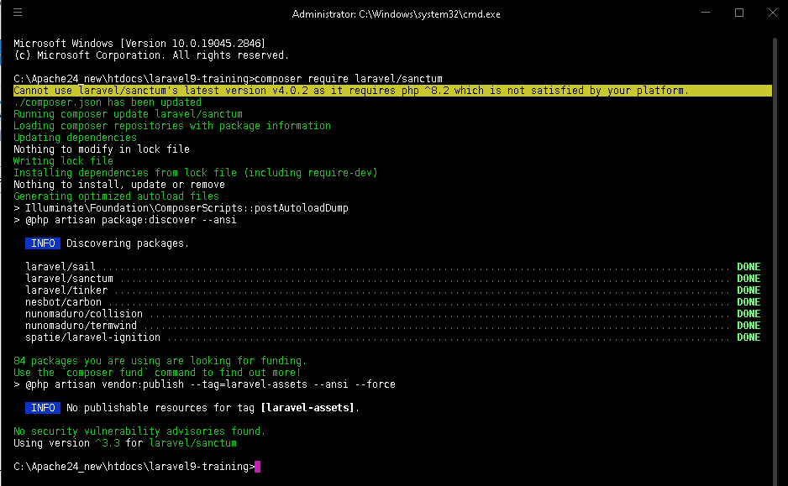
2. Publish the Sanctum, paste the following command and hit enter
php artisan vendor:publish --provider="Laravel\Sanctum\SanctumServiceProvider"
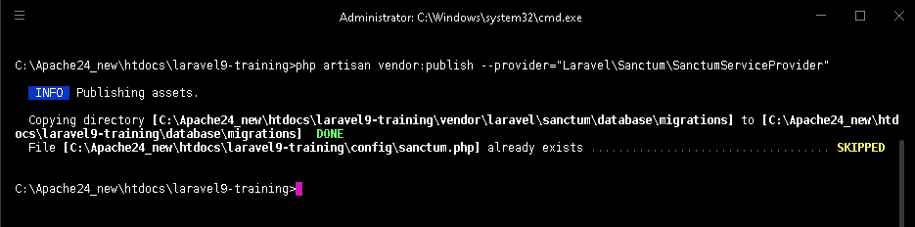
It says already exists, meaning already publish…

3. Create AuthController, in the terminal paste the following command and hit enter
php artisan make:controller Auth/AuthController
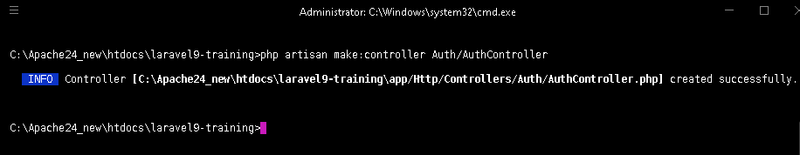
The AuthController is created inside of App\Http\Controllers\Auth

Inside of the AuthController paste the code snippet

<?php

namespace App\Http\Controllers\Auth;

use App\Http\Controllers\Controller;
use Illuminate\Http\Request;
use Illuminate\Support\Facades\Auth;
use Illuminate\Validation\ValidationException;

class AuthController extends Controller
{
//! Display the login view.
public function create()
{
if(Auth::check()) {
return redirect()->intended('/');
}
return view('auth.login');
}

//! Handle an incoming authentication request.
public function store(Request $request)
{
$credentials = $request->validate([
'employee_code' => 'required|string',
'password' => 'required|string',
]);

if(Auth::attempt($credentials, true)) {
$request->session()->regenerate();
return redirect()->intended('/');
}

throw ValidationException::withMessages([
'login' => trans('auth.failed'),
]);
}

//! Destroy an authenticated session.
public function destroy(Request $request)
{
Auth::guard('web')->logout();
$request->session()->invalidate();
$request->session()->regenerateToken();
return redirect('/login');
}
}

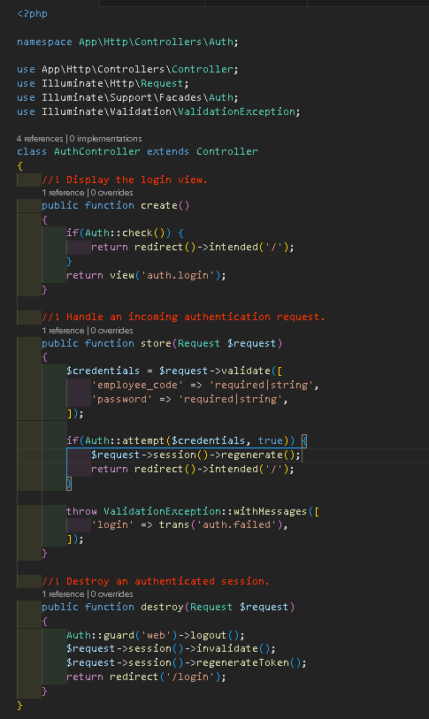

4. Create RegisterController, in the terminal paste the following command and hit enter
php artisan make:controller Auth/RegisterController
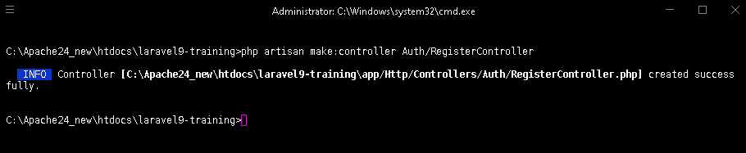
The RegisterController is created inside of App\Http\Controllers\Auth

Inside of the RegisterController paste the code snippet

<?php

namespace App\Http\Controllers\Auth;

use App\Http\Controllers\Controller;
use App\Models\User;
use Illuminate\Auth\Events\Registered;
use Illuminate\Http\Request;
use Illuminate\Support\Facades\Hash;

class RegisterController extends Controller
{
//! Display the registration view.
public function create()
{
return view('auth.login');
}

//! Handle an incoming registration request.
public function store(Request $request)
{
$request->validate([
'employee_code' => 'required|string|max:255|unique:'.User::class,
'name' => 'required|string|max:255',
'password' => 'required|string',
]);

$user = User::create([
'employee_code' => $request->employee_code,
'name' => $request->name,
'password' => Hash::make($request->password),
]);

event(new Registered($user));
}
}

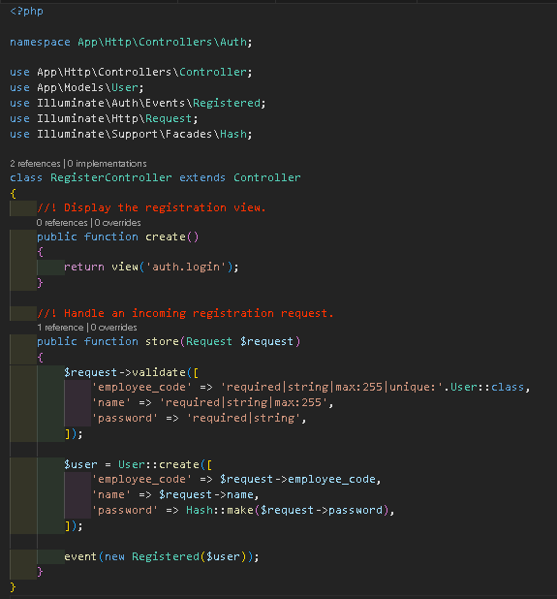

5. In web.php copy and paste the following code snippet

<?php

use Illuminate\Support\Facades\Route;
use App\Http\Controllers\SpaController;
use App\Http\Controllers\Auth\AuthController;
use App\Http\Controllers\Auth\RegisterController;

/*
|--------------------------------------------------------------------------
| Web Routes
|--------------------------------------------------------------------------
|
| Here is where you can register web routes for your application. These
| routes are loaded by the RouteServiceProvider within a group which
| contains the "web" middleware group. Now create something great!
|
*/

Route::get('/login', [AuthController::class, 'create'])->name('login');
Route::post('/login', [AuthController::class, 'store']);
Route::post('/register', [RegisterController::class, 'store']);

Route::middleware('auth')->group(function () {
Route::get('/{any?}', [SpaController::class, 'index'])->where('any', '.*');
Route::post('/logout', [AuthController::class, 'destroy'])->name('logout');
});

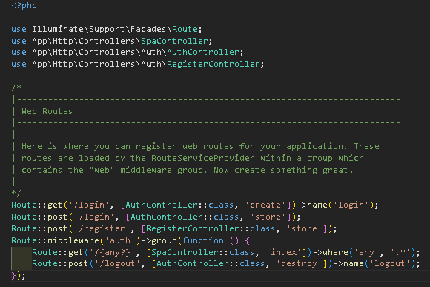

6. In resources/views create auth folder, inside of auth folder create login.blade.php and paste
the following code snippet

<!DOCTYPE html>
<html lang="en">
<head>
<meta charset="UTF-8">
<meta name="viewport" content="width=device-width, initial-scale=1.0">
<meta http-equiv="X-UA-Compatible" content="ie=edge">
<title>Laravel 9 Training</title>

@vite(['resources/css/app.css', 'resources/js/app.js'])

</head>
<body>
<div id="app">
<Login></Login>
</div>
</body>
</html>

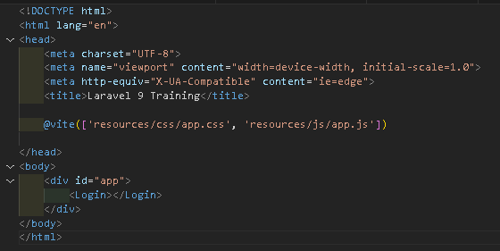
Don’t forget to change this
Title in relate to your
system/project

7. In resources/view, inside of layouts folder paste the following code snippet in app.blade.php

<!DOCTYPE html>
<html lang="en">
<head>
<meta charset="UTF-8">
<meta name="viewport" content="width=device-width, initial-scale=1.0">
<meta http-equiv="X-UA-Compatible" content="ie=edge">
<meta name="csrf-token" content="{{ csrf_token() }}">
<title>Laravel 9 Training</title>

@vite(['resources/css/app.css', 'resources/js/app.js'])

</head>
<body>
<div id="app">
<App></App>
</div>
@if(auth()->check())
<script>
window.user = @json(auth()->user())
</script>
@endif
</body>
</html>

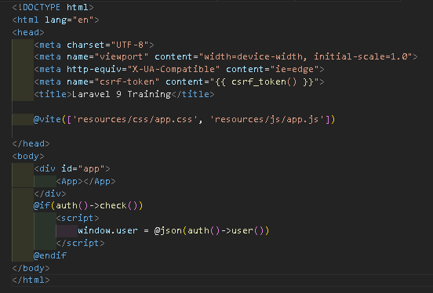
Don’t forget to change this
Title in relate to your
system/project

8. Login to phpMyAdmin in the browser and create a database
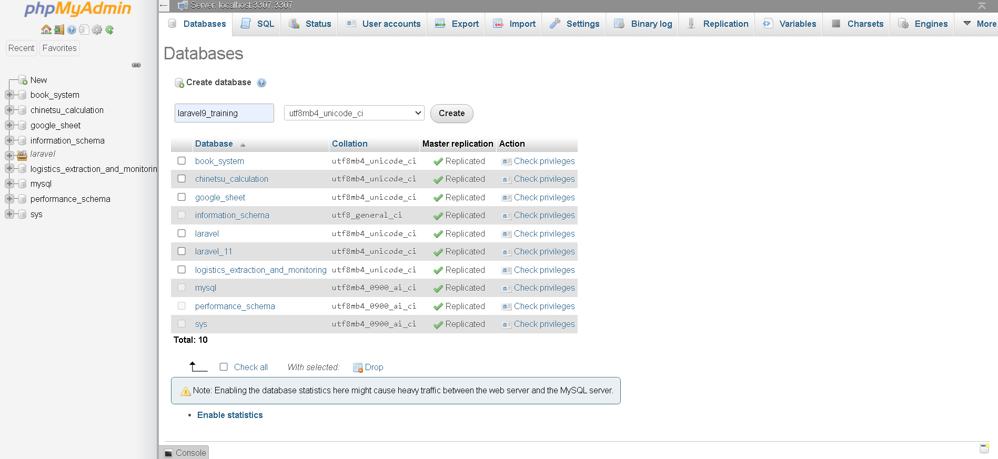
Click New
1
Type the database name here
then click create
2
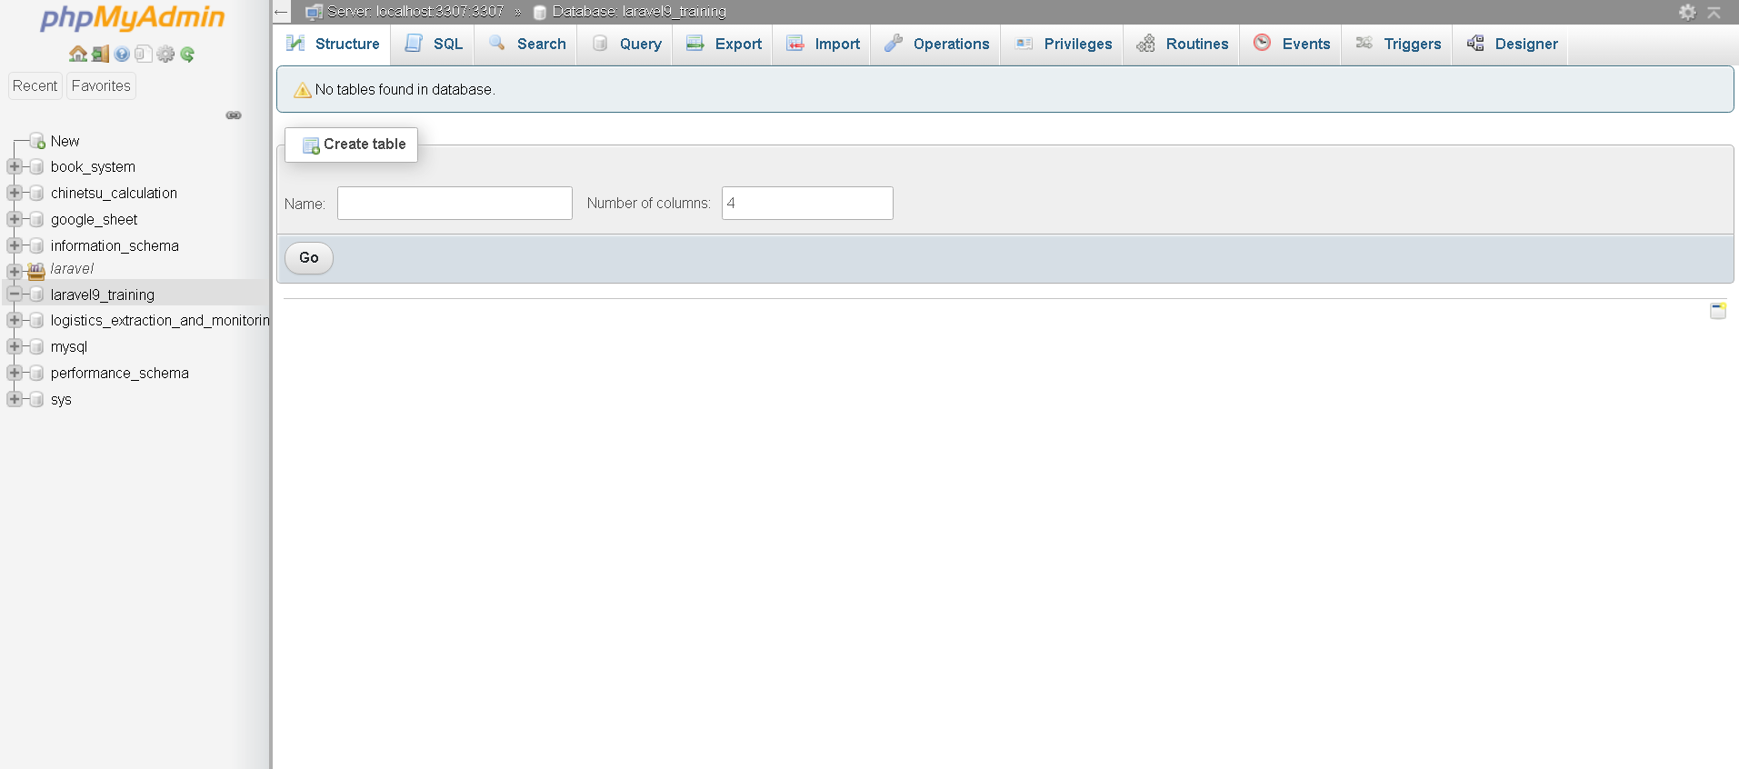
Our database is now created

9. Open the .env of the system/project connect to database by changing the following
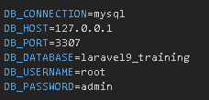

10. Modify the create_users_table in database\migrations, paste the following code snippet

<?php

use Illuminate\Database\Migrations\Migration;
use Illuminate\Database\Schema\Blueprint;
use Illuminate\Support\Facades\Schema;

return new class extends Migration
{
/**
* Run the migrations.
*
* @return void
*/
public function up()
{
Schema::create('users', function (Blueprint $table) {
$table->id();
$table->string('employee_code')->unique();
$table->string('name');
$table->string('password');
$table->rememberToken();
$table->timestamps();
});
}

/**
* Reverse the migrations.
*
* @return void
*/
public function down()
{
Schema::dropIfExists('users');
}
};

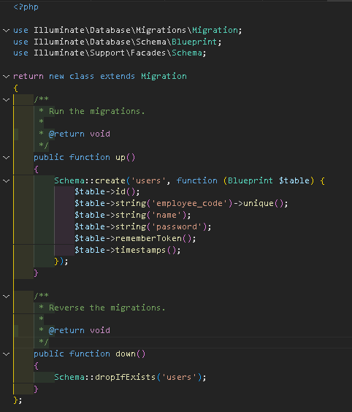

11. Modify User model in app\Models, and paste the following code snippet

<?php

namespace App\Models;

// use Illuminate\Contracts\Auth\MustVerifyEmail;
use Illuminate\Database\Eloquent\Factories\HasFactory;
use Illuminate\Foundation\Auth\User as Authenticatable;
use Illuminate\Notifications\Notifiable;
use Laravel\Sanctum\HasApiTokens;

class User extends Authenticatable
{
use HasApiTokens, HasFactory, Notifiable;

protected $fillable = [
'employee_code',
'name',
'password',
];

protected $hidden = [
'password',
'remember_token',
];
}

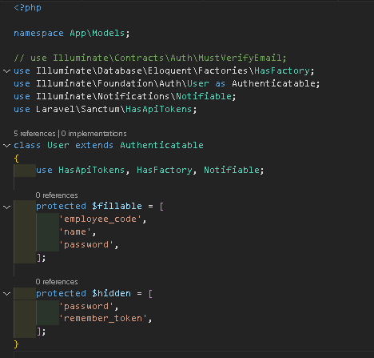

Migrate the tables, in the terminal paste the following command and hit enter
php artisan migrate
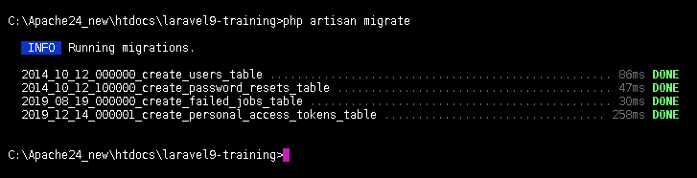

If we check our database, our migration is there
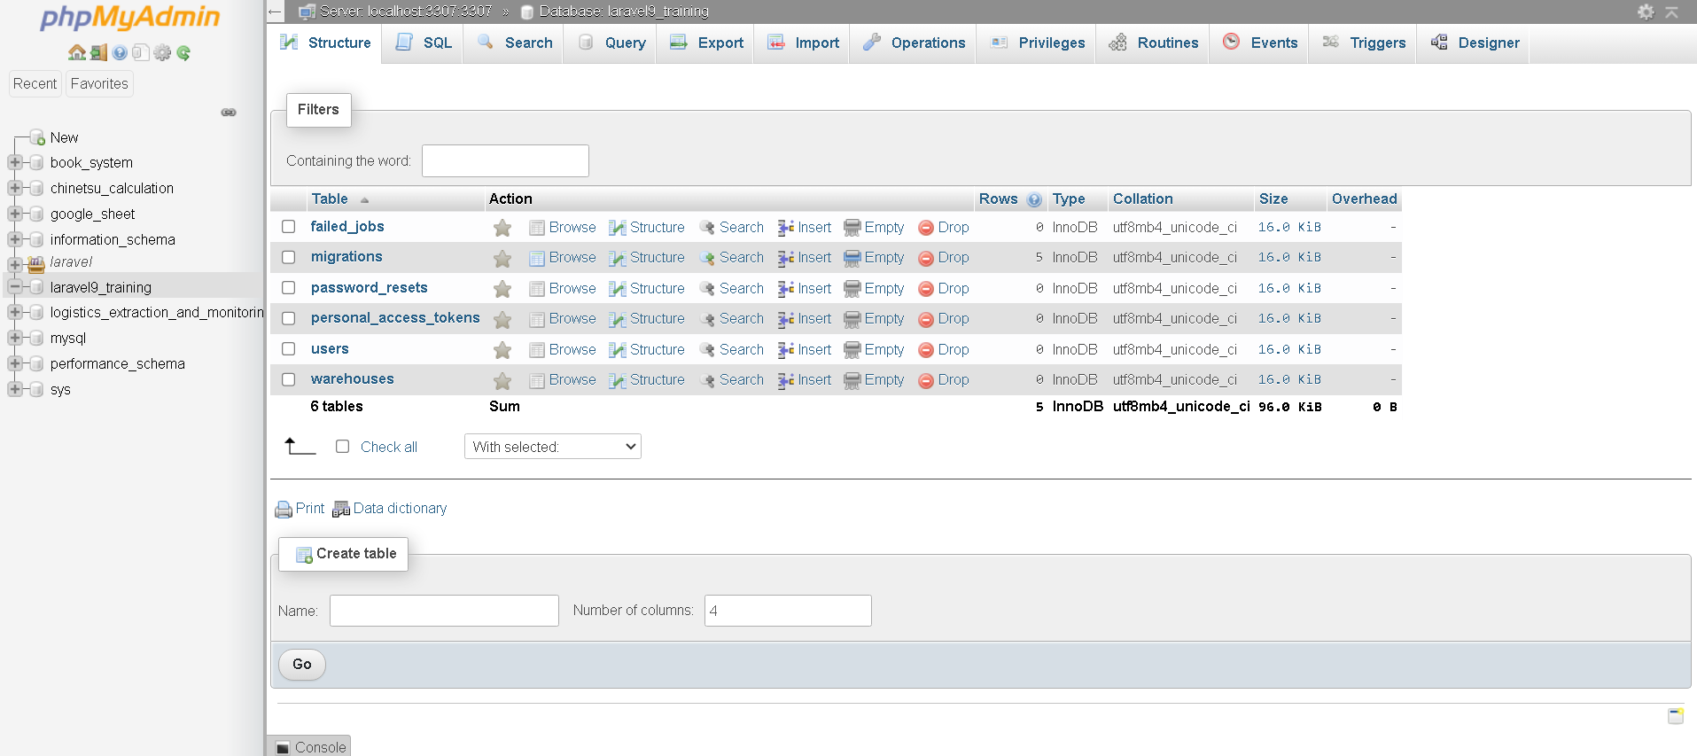

12. Create a Login.vue in resources/js/components/pages and paste the code snippet

<template>
<div>
<v-sheet :elevation="10" rounded="xl" class="container pa-5" width="35%">
<v-card-title><h2>{{isLogin ? "LOGIN" : "REGISTER"}}</h2></v-card-title>
<v-card-text class="d-flex flex-column" style="gap: 2px;">
<div v-for="(item, i) in isLogin ? login : register " :key="i">
<div>{{ item.title }}</div>
<v-text-field
density="comfortable"
:prepend-inner-icon="item.icon"
v-model="credentials[item.value]"
></v-text-field>
</div>
</v-card-text>
<div class="pa-4 d-flex flex-column text-center" style="gap: 30px;">
<v-btn size="large" block color="primary" @click="LoginRegister()">
{{ isLogin ? "Login" : "Register"}}
</v-btn>
<div>{{ isLogin ? "Don't" : "Already" }} have an account?
<u @click="IsLogin()" style="cursor: pointer;">{{ isLogin ? "Register" : "Login"}}</u>
</div>
</div>
</v-sheet>
</div>
</template>

<script>
export default {
data() {
return {
credentials: {},
login: [
{title: 'Employee Code', value: 'employee_code', icon: 'mdi-account'},
{title: 'Password', value: 'password', icon: 'mdi-lock'},
],
register: [
{title: 'Name', value: 'name', icon: 'mdi-account'},
{title: 'Employee Code', value: 'employee_code', icon: 'mdi-account'},
{title: 'Password', value: 'password', icon: 'mdi-lock'},
],
isLogin: true,
}
},

methods: {
IsLogin() {
this.isLogin = !this.isLogin
this.credentials = {}
},

async LoginRegister() {
try {
if(this.isLogin) {
await axios.post('login', this.credentials)
location.reload();
} else {
await axios.post('register', this.credentials)
location.reload();
}
this.credentials = {}
} catch (error) {
let result = ''
let err = error.response.data.errors
for (let index in err) {
const element = err[index];
result += '* ' + element + '\n'
}
alert(result)
}
}
},
}
</script>

<style scoped>
.container {
top: 50%;
left: 50%;
position: absolute;
transform: translate(-50%, -50%);
}
</style>
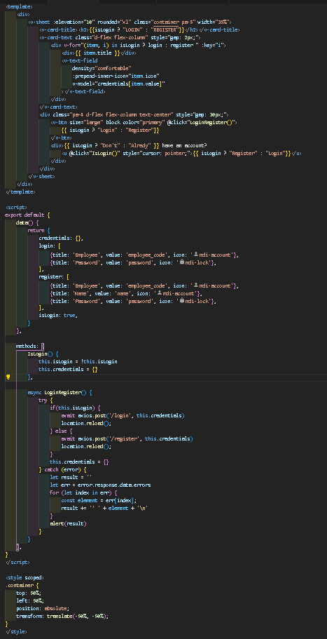

13. Modify App.js in resources/js, paste the following code snippet
Comment or remove the import { createApp } from 'vue'

import { createApp } from 'vue/dist/vue.esm-bundler'
import Login from './components/pages/Login.vue'

const app = createApp({})
app.component('App', App)
app.component('Login', Login)

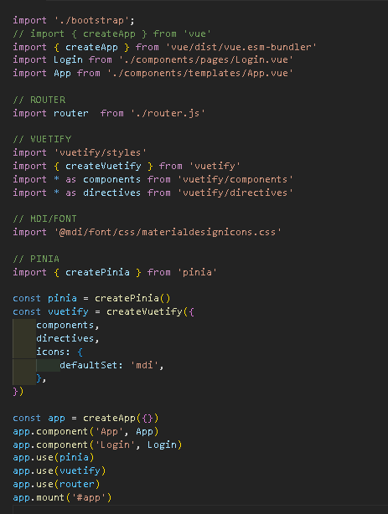

14. Add this code snippet inside of our router.js in resources/js

const Login = () => import('./components/pages/Login.vue');

{
path: '/login',
component: Login,
name: 'Login',
},

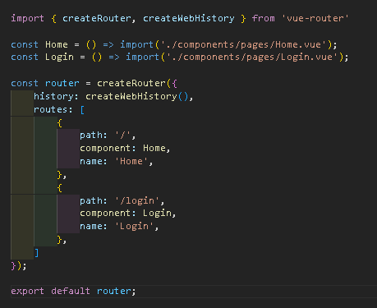

15. If you plan to utilize the api.php, uncomment the following code in App\Http\Kernel.php
from:
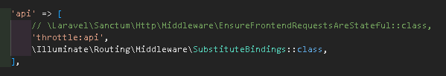

to:
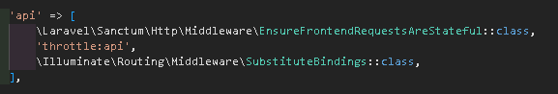

You can now use the api, don’t forget to put your route’s inside the middleware
If not work paste this following code snippet

\App\Http\Middleware\EncryptCookies::class,

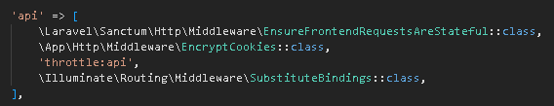

16. For logout function paste the following code inside of App.vue
Paste the code inside v-app-bar

<v-btn @click="Logout()">Logout</v-btn>

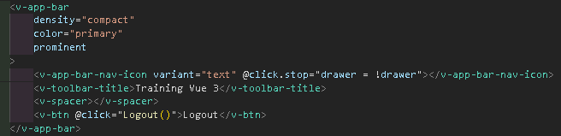

Paste the code inside of methods

async Logout() {
await axios.post('logout');
location.reload();
}

